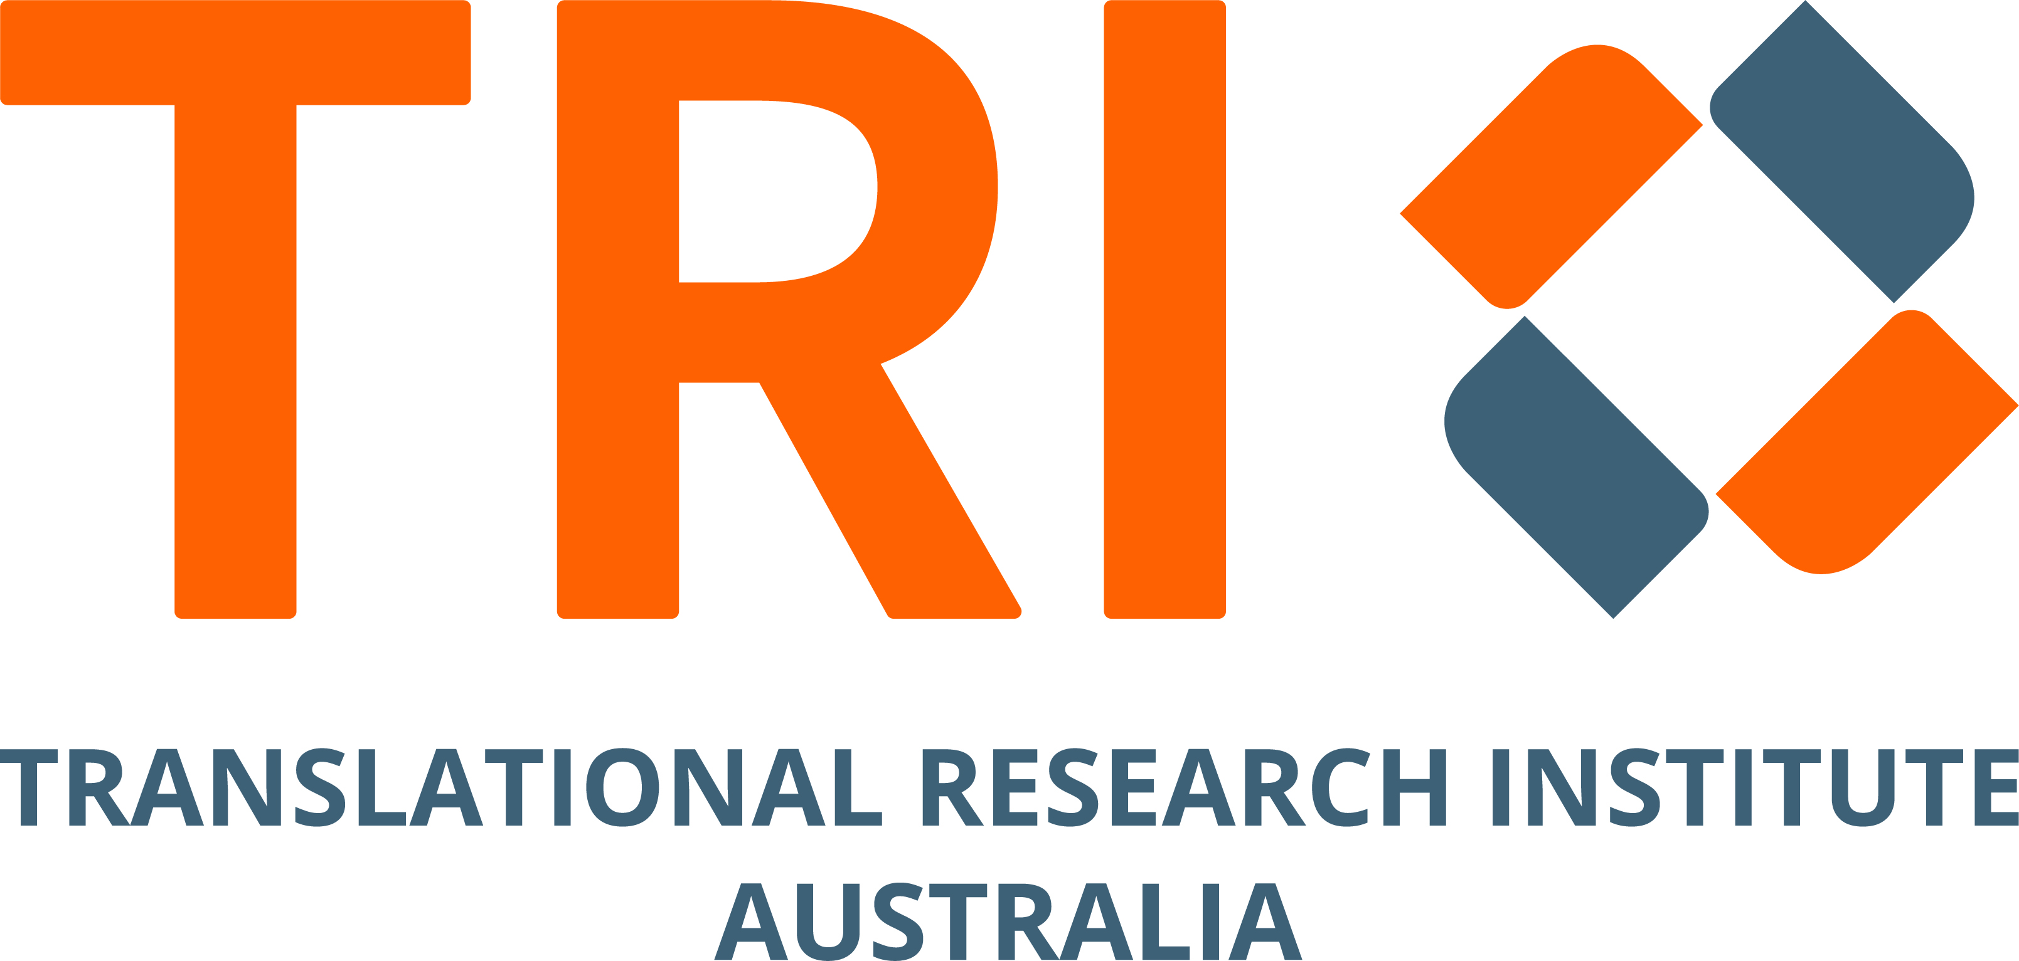
TRI-500-037 TRI Position Description

Philanthropy Manager
Translational Research Institute (TRI)

1. About the TRI and the TRI Foundation
TRI Foundation supports the Translational Research Institute (TRI) to accelerate the journey from laboratory discovery to real-world health solutions. TRI is one of the southern hemisphere's largest translational research facilities, housing over 1,100 researchers, clinicians and industry employees working to transform scientific breakthroughs into treatments that save and improve lives. TRI Foundation raises philanthropic support for critical programs including Early and Mid-Career Researcher (EMCR) development, SPARQ-ed student engagement initiatives, and research infrastructure that empowers TRI-based researchers to deliver world-class health solutions.

2. Position Purpose
The Philanthropy Manager is a new role and is responsible for the acquisition and stewardship of major gifts, strategic partnerships and fundraising activities that advance TRI Foundation's mission. This role focuses on building and maintaining meaningful relationships with individual philanthropists, corporate partners, foundations and donors to secure transformational support for TRI's research programs. The Philanthropy Manager works collaboratively as part of TRI’s Corporate Affairs and Marketing team to implement comprehensive fundraising strategies, deliver exceptional donor experiences, and achieve revenue targets for TRI Foundation.

3. Key Responsibilities
Major Gifts Management (50%)
- Identify, qualify, cultivate, solicit, and steward a portfolio of major gift prospects and donors (gifts of $5,000+)
- Develop and implement personalised engagement strategies for individual donors aligned with their philanthropic interests and capacity
- Prepare compelling proposals, cases for support, and funding submissions tailored to individual donor priorities
- Coordinate face-to-face donor meetings, facility tours, and cultivation events in collaboration with TRI leadership and researchers with support from the Head of Corporate Affairs and relevant team members
- Manage donor stewardship activities including impact reporting, recognition, and ongoing relationship development
- Maintain accurate and current records of all donor interactions, moves management, and gift documentation
- Achieve annual revenue targets for major gifts.
Partnership Development (25%)
- Identify and develop strategic partnerships with corporate organisations, trusts, and foundations aligned with TRI Foundation priorities
- Research and analyse potential corporate partners to develop targeted engagement strategies
- Prepare partnership proposals including corporate partnerships, program sponsorships, and multi-year giving arrangements
- Negotiate partnership agreements ensuring mutual value and alignment with organisational objectives
- Manage partnership stewardship including benefit delivery, impact reporting, and relationship management
- Support the TRI Foundation Giving Circle recruitment and member engagement activities
- Collaborate with TRI researchers and program managers to develop fundable projects and compelling partnership opportunities with support from the Head of Corporate Affairs and relevant team members.
Fundraising Appeals, Operations & Team Support (25%)
- Contribute to the development and implementation of TRI Foundation's annual fundraising plan including acquisition and stewardship strategies
- Lead campaign development and execution for special initiatives and priority projects including appeals and a collective National MRI Giving Day initiative
- Prepare fundraising materials including donor communications, impact reports, case statements, and promotional content
- Collaborate with Corporate Affairs and Marketing team members to develop donor-facing content and storytelling
- Assist with fundraising events including cultivation events, donor recognition activities, and stewardship functions
- Support grant applications and acquittal processes as required
- Participate in team meetings, planning sessions, and professional development activities.

4. Reporting Relationships
The Philanthropy Manager reports to the Head of Corporate Affairs, Translational Research Institute.

5. Key Relationships
The Philanthropy Manager will build numerous internal and external relationships which include:
Internal:
- Director Corporate Affairs and Marketing
- Head of Corporate Affairs
- TRI Foundation Board members
- TRI Foundation Steering Committee
- TRI Executive Leadership Team and associated Business Unit team members
- TRI researchers and program managers
- Corporate Affairs and Marketing team members
- Finance and Administration teams
External:
- Individual major donors and prospects
- Corporate partners and prospects
- Foundation and trust representatives
- Fundraising and philanthropic sector networks

6. Selection Criteria - Experience, Knowledge, Skills, Abilities and Qualifications
Experience
- Minimum 5 years demonstrated experience in major gifts and partnership fundraising with a proven track record of securing significant donations
- Experience using donor databases to manage portfolios and track donor engagement
Desirable:
- Experience in medical research, health, or scientific fundraising environments
- Experience with corporate partnership development and negotiation
- Experience with planned giving and bequest programs
- Experience working with volunteer boards and committees.
Knowledge, Skills and Abilities
- Demonstrated ability to identify, cultivate, solicit, and steward major gift donors through personalised relationship management
- Strong understanding of fundraising principles, donor psychology, and ethical fundraising practices
- Excellent written and verbal communication skills with ability to prepare compelling proposals, cases for support, and donor correspondence
- Demonstrated ability to build and maintain relationships with diverse stakeholders including high-net-worth individuals, corporate leaders, and senior executives
- Strong organisational and time management skills with ability to manage multiple priorities and work independently
Desirable:
- Understanding of translational research and medical science landscape
- Knowledge of Queensland philanthropic landscape and networks
- Project management experience and skills
Qualifications
- Tertiary qualification and/or certified training in a relevant discipline (e.g., psychology, fundraising, business, communications, marketing, research) or equivalent experience
Desirable:
- Professional fundraising certification or membership (e.g., CFRE, FIA membership)

7. Key Competencies
- Relationship Building: Exceptional interpersonal skills with ability to establish trust and credibility with diverse stakeholders
- Strategic Thinking: Ability to develop and implement targeted cultivation strategies aligned with organisational priorities
- Communication Excellence: Outstanding written and verbal communication with ability to articulate complex concepts clearly
- Persuasion and Negotiation: Skilled in making compelling cases for support and negotiating mutually beneficial partnerships
- Results Orientation: Self-motivated with strong drive to achieve targets and deliver measurable outcomes
- Collaboration: Team player who works effectively across organisational boundaries to achieve shared goals
- Adaptability: Flexible and responsive to changing priorities in a dynamic environment
- Attention to Detail: Thorough and accurate in all work with commitment to quality
- Initiative: Proactive problem-solver who identifies opportunities and takes action
- Emotional Intelligence: Perceptive and empathetic with strong ability to understand donor motivations and perspectives.

8. Workplace Health & Safety
All employees have a responsibility under the Work Health and Safety Act 2011 to take reasonable care for their own health and safety and that of others in the workplace. This includes following safety procedures, using equipment appropriately, reporting hazards and incidents, and participating in training as required.

9. Equity & Diversity
The TRI Foundation is committed to creating an inclusive workplace that promotes and values diversity and inclusion. We actively encourage applications from people of all ages, nationalities, abilities, and cultures including Aboriginal and Torres Strait Islander peoples.

10. Other Requirement
- Current driver's license and willingness to travel within Queensland for donor meetings
- Flexibility to work occasional evenings and weekends for donor events and cultivation activities
- Current Working with Children Check (Blue Card) or willingness to obtain
- Satisfactory National Police Certificate
- Right to work in Australia.

