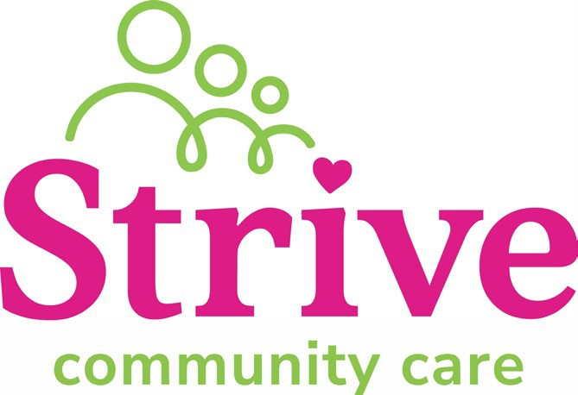

Position Description

Position Title: | Quality & Safeguarding Manager
Department: | Quality & Safeguarding |  | Assessed:
Position Reports to  (position title): |  | Managing Director
Direct Reports (position titles): |  | Quality & Safeguarding Team Leader

Key relationships
Internal | External
- Managing Director  - Senior Leadership Team  - Regional Manager  - Frontline Staff | - Relevant QLD Government Departments (Department of Child Safety, Youth Justice, QLD Health, etc)  - National Disability Insurance Agency (NDIA)  - OOHC & NDIS Industry Bodies  - Collaborative Partners (partner organisations and consultants)

Qualifications and experience
- Tertiary qualification in a relevant discipline (health/allied health/social services sector) with significant experience at a senior management level in community services.
- Demonstrated knowledge in relation to contemporary issues, legislation, and standards impacting on community services, particularly the OOHC sector, as they relate to client safety and governance.
- Extensive experience in leading the formulation, development, implementation and evaluation of quality, client safety frameworks, strategies, policies, plans, systems, and procedures.
- Demonstrated expertise in leading accreditation processes and achieving successful outcomes.
- Strong financial literacy skills and the ability to manage project and client funding within contractual and budgetary parameters.
- Strong influencing skills and demonstrated achievements in stakeholder engagement.
- High-level communication, negotiation, and interpersonal skills.
- Proven ability to provide strong leadership to senior-level managers.

- Professional resilience and proven capacity to work at a senior management or executive level.
- Ability to think creatively and foster a culture of energy and innovation around achieving outcomes for clients and communities.
- A current QLD driver’s licence.
- Evidence of entitlement to work in Australia.
- National Criminal History Check (from within the last 12 months)
- A valid Paid Employment Blue Card (QLD Working With Children Check)
- A valid Yellow Card (Disability Worker Screening)
- Flexible in the hours at times to meet the reasonable demands of the position

Key Responsibilities
Purpose, Vison and Values | - Actively develop and promote the desired organisational culture by ensuring all interactions, documentation, and communications align with and support the organisation’s purpose, vison and values.  - Provide and promote a welcoming and safe environment for children, young people, and people with a disability, along with staff.  - Model core leadership values of Transparency, Accountability, and Engagement.
Strategic, business, and service planning and reporting | - Participate in the development and implementation of the organisation’s strategic direction in consultation with management, staff, clients, and other key stakeholders.  - Lead the formulation and conversion of strategic plans into annual operational plans in each Region.  - Keep abreast of government reforms, industry trends, and sector developments to ensure currency of knowledge, modify plans and procedures anticipate implications to service.  - Manage the annual budget for the Quality & Safeguarding Department, monitor expenditure, and take appropriate and timely measures to address any variance.  - Establish and monitor appropriate, reliable, and valid indicators, measures and targets for department-related performance.  - Report monthly to the Managing Director on the progress of annual work objectives.
Community engagement and relationships | - Promote and represent Strive to a range of stakeholders to ensure the organisation is recognised as a leading provider in the community services sector.  - Ensure effective relationships exist with key government representatives, relevant provider networks, and other stakeholders.  - Be proactive and responsive to identified community needs and issues that may drive organisation growth and real change for the community we service.  - Assist in future growth of Strive to enable the delivery of high-quality  services within a growing footprint in QLD.

Service design and delivery, | - Ensure the provision of high quality, consistent, financially viable services to best satisfy the needs of the client, relevant to Government agencies, tender specifications or service level agreements with the wider community and/or stakeholders.  - Develop a committed and cohesive management team focused on the principles of continuous improvement.  - Review existing business models and map service delivery to encapsulate sector reforms and develop and deliver operational plans.  - Oversee feedback review process and program evaluations to ensure high standards of satisfaction are maintained in all services.  - Contribute to long-term sustainability of funding through quality service delivery, innovative practice, and strong relationship management within a consumer-directed care model.
Provide leadership and management | - Develop a supportive environment that fosters open communication, innovative problem solving, responsible risk taking and performance ownership.  - Lead and mentor staff to work closely with key business stakeholders to introduce and embed a quality and practice improvement culture.  - Provide expert advice to the Managing Director and other stakeholders relating to quality, and customer safety.  - Provide strategic leadership for innovation, change and coordinated responses to emerging needs in client safety and quality management processes, accreditation and systems.  - Develop Key Performance Indicators (KPI’s), Performance Development Plans (PDP’s), and conduct performance reviews for direct reports and ensure performance management cascades through the department.
Strategic management | - Drive ongoing analysis and review of Quality Systems across service delivery areas to identify opportunities for improvement.  - Provide expert advice to the Senior Leadership Team on the regulatory and quality reporting landscape focussing on a proactive approach to Quality and Safeguarding practices.  - Assess and respond to the impact of changes in the operating environment ensuring a high level of integration with Strive’s strategic direction.  - Manage and implement workforce planning and structure changes, making recommendations as appropriate to ensure adequate resources and skills are available to meet organisation needs.
Operational management | - Develop a framework for the establishment of strategic and operational quality systems and outcomes.  - Ensure effective systems are in place to support continuous improvement and achieve/maintain relevant accreditation.  - Review current quality improvement activities and recommend, lead and implement strategies, plans and goals to ensure continuous quality improvements.  - Establish reporting mechanisms and performance indicators which inform, measure and lead the organisation in best quality management practices.  - Review and keep abreast of contemporary matters in relation to quality by actively seeking and participating in relevant industry quality forums.  - In conjunction with the relevant stakeholders, establish action plans to prepare the organisation for its various external accreditations, undertake gap analysis and approaches to ensure standards are met.  - Reviewing the current customer safety and well-being practices and processes and develop a robust approach to risk management and mechanisms for managing, recording and reporting as appropriate.

Terms of appointment
Appointment period: Permanent
FTE: Full-time (1.0 FTE).

Prepared by: | Ryan Dempsey
Position Title: | Managing Director
Date: | 28 August 2025
Approved by: | Ryan Dempsey
Position Title: | Managing Director
Date: | 28 August 2025

