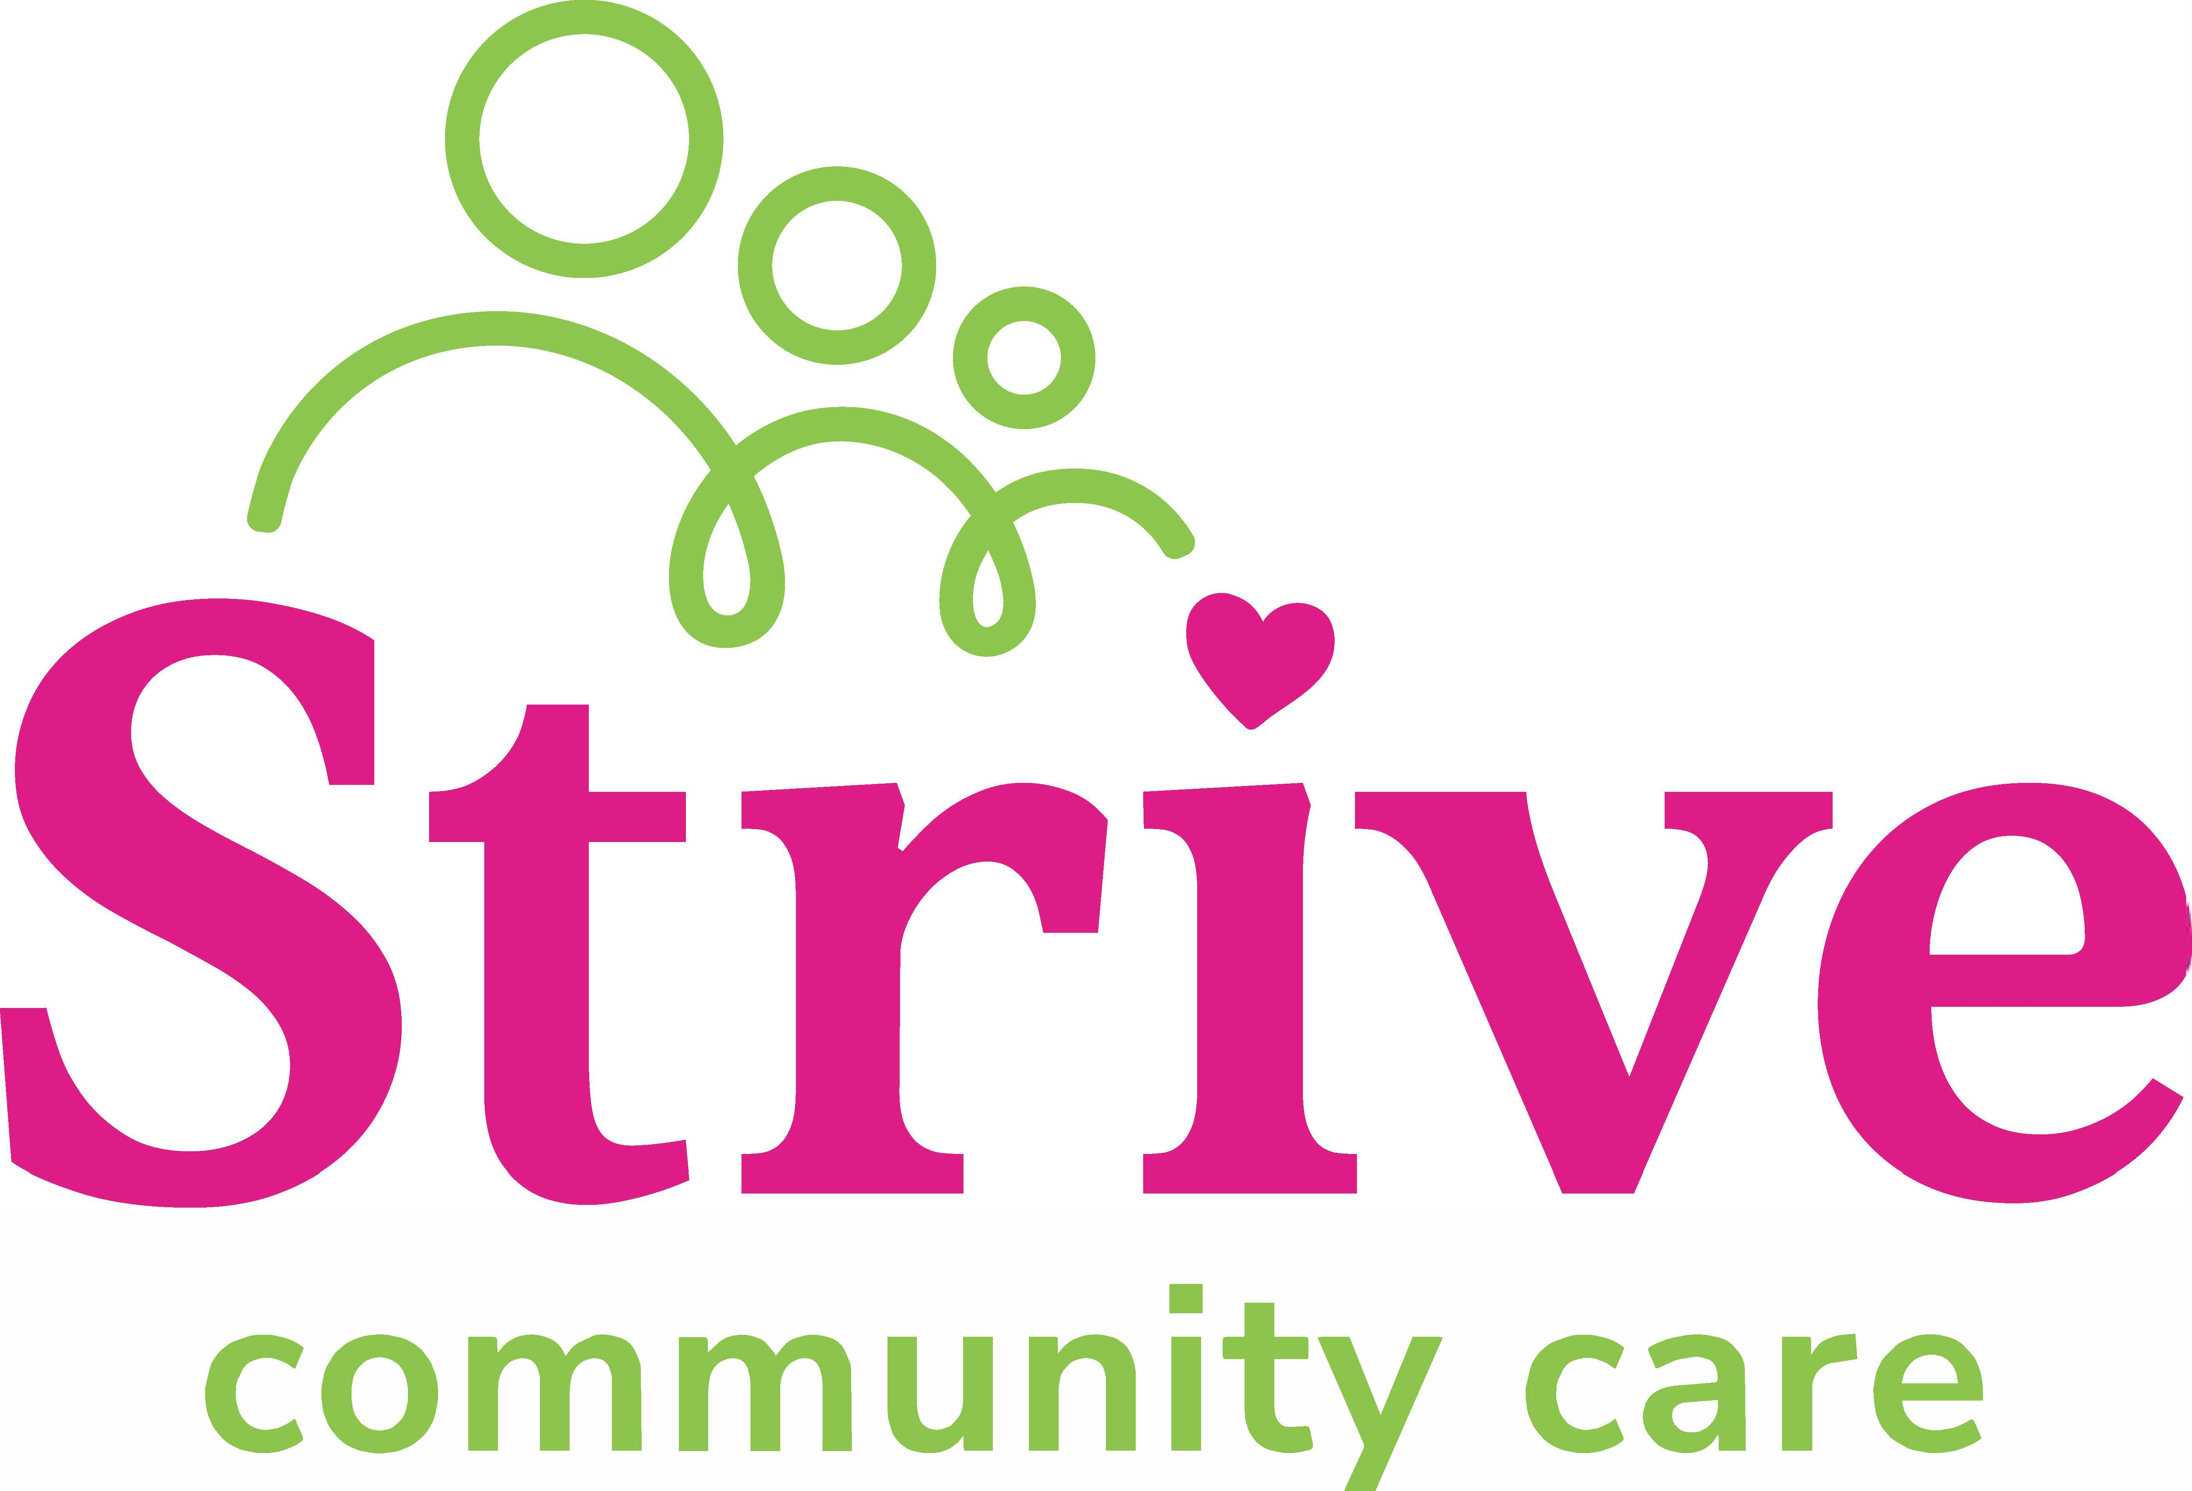

**Position Description**

|  |  |  |  |  |
| --- | --- | --- | --- | --- |
| **Position Title:** | Care Services Manager | | | |
| **Department:** | Operations | | **Assessed:** |  |
| **Position Reports to (position title):** | | Managing Director | | |
| **Direct Reports (position titles):** | | Regional Manager | | |

|  |
| --- |
| **Key relationships** |
| |  |  | | --- | --- | | **Internal** | **External** | | * Managing Director * Senior Leadership Team * Regional Manager * Frontline Staff | * Relevant QLD Government Departments (Department of Child Safety, Youth Justice, QLD Health, etc) * National Disability Insurance Agency (NDIA) * OOHC & NDIS Industry Bodies | |

|  |
| --- |
| **Qualifications and experience** |
| 1. Tertiary qualification in a relevant discipline (health/allied health/social services sector) with significant experience at a senior operational management level. 2. Detailed knowledge in relation to contemporary issues, legislation and standards impacting on community services, particularly permanency support (OOHC) programs. 3. Extensive experience in child and family services operational management, contract management, service coordination, service design and development. 4. Strong financial literacy skills and the ability to manage project and client funding within contractual and budgetary parameters. 5. Strong influencing skills and demonstrated achievements in stakeholder engagement. 6. High-level communication, negotiation, and interpersonal skills. 7. Proven ability to provide strong leadership to senior-level managers. 8. Professional resilience and proven capacity to work at a senior management or executive level. 9. Ability to think creatively and foster a culture of energy and innovation around achieving outcomes for clients and communities. 10. A current QLD driver’s licence. 11. Evidence of entitlement to work in Australia. 12. National Criminal History Check (from within the last 12 months) 13. A valid Paid Employment Blue Card (QLD Working With Children Check) 14. A valid Yellow Card (Disability Worker Screening) 15. Flexible in the hours at times to meet the reasonable demands of the position |

|  |  |
| --- | --- |
| **Key Responsibilities** | |
| **Purpose, Vison and Values** | * Actively develop and promote the desired organisational culture by ensuring all interactions, documentation, and communications align with and support the organisation’s purpose, vison and values. * Provide and promote a welcoming and safe environment for children, young people, and people with a disability along with staff. * Model core leadership values of Transparency, Accountability, and Engagement. |
| **Strategic, business, and service planning and reporting** | * Participate in the development and implementation of the organisation’s strategic direction in consultation with management, staff, clients, and other key stakeholders. * Lead the formulation and conversion of strategic plans into annual operational plans in each Region. * Keep abreast of government reforms, industry trends, and sector developments to ensure currency of knowledge, modify plans and procedures anticipate implications to service. * Manage the annual budgets for OOHC and NDIS services, monitor income and expenditure, and take appropriate and timely measures to address any variance. * Establish and monitor appropriate, reliable, and valid indicators, measures and targets for service-related performance. * Report monthly to the Managing Director on the progress of annual work objectives. |
| **Community engagement and relationships** | * Promote and represent Strive to a range of stakeholders to ensure the organisation is recognised as a leading provider in the community services sector. * Ensure effective relationships exist with key government representatives, relevant provider networks, and other stakeholders. * Be proactive and responsive to identified community needs and issues that may drive organisation growth and real change for the community we service. * Assist in future growth of Strive to enable the delivery of high-quality   services within a growing footprint in QLD. |
| **Service design and delivery,** | * Ensure the provision of high quality, consistent, financially viable services to best satisfy the needs of the client, relevant to Government agencies, tender specifications or service level agreements with the wider community and/or stakeholders. * Develop a committed and cohesive management team focused on the principles of continuous improvement. * Review existing business models and map service delivery to encapsulate sector reforms and develop and deliver operational plans. * Oversee feedback review process and program evaluations to ensure high standards of satisfaction are maintained in all services. * Contribute to long-term sustainability of funding through quality service delivery, innovative practice, and strong relationship management within a consumer-directed care model. |

|  |
| --- |
| **Terms of appointment** |
| Appointment period: Permanent  FTE: Full-time (1.0 FTE). |

|  |  |
| --- | --- |
| **Prepared by:** | **Daisy Dempsey** |
| **Position Title:** | **People & Culture Manager** |
| **Date:** | **9 May 2025** |
| **Approved by:** | **Ryan Dempsey** |
| **Position Title:** | **Managing Director** |
| **Date:** | **12 May 2025** |