Fundraising at RSPCA Queensland
A Summary for Senior Fundraising Manager Candidates
April 2025

Overview
Fundraising is central to RSPCA Queensland’s mission to help animals live free from suffering and find loving homes. With less than 6% of our income coming from government, we rely on the generosity of individuals, businesses, and community partners to deliver critical services across companion animal care, wildlife rehabilitation, and animal welfare advocacy.
In FY24, income from fundraising and bequests exceeded $39 million, accounting for two-thirds of RSPCA Queensland’s total revenue. These funds support everything from shelter operations to emergency rescues, cruelty investigations, and veterinary care. Our approach is designed to be donor-centric, scalable, and sustainable, with a growing emphasis on innovation, data, and supporter experience.

Key Programs and Channels
Gifts in Wills
One in three animals we care for is supported by gifts in wills. In FY24, legacy giving generated over $24 million, making it our largest income stream - and the largest bequest program in Queensland. With over 4,200 confirmed pledgers and a pipeline valued at nearly $500 million, this channel presents RSPCA Queensland’s greatest long-term growth opportunity. We invest in integrated campaigns, events, and personalised stewardship to grow this life-changing support.
Fundraising
Our core fundraising programs aim to inspire Queenslanders to support animal welfare through regular giving, appeals, and community-led efforts.
- Regular Giving: A reliable revenue stream raising $3.5 million in FY24 from over 12,500 monthly donors, acquired through face-to-face, digital, and telemarketing channels.
- Appeals: Our seasonal campaigns (Tax, Christmas, Giving Day) raised $1.7 million, anchored in compelling animal stories and donor impact.
- Major Gifts: Contributed $2.7 million in FY24, supporting high-impact programs and initiatives. We offer personalised engagement, tailored proposals, and opportunities for donors to connect meaningfully with our work.
- Community Fundraising: From Facebook birthday fundraisers to DIY events, this growing area empowers supporters to champion our mission in their own way, backed by digital tools and support.

Partnerships
Our partnerships program generated $1.5 million in FY24, with over $1 million in contra. We work with like-minded businesses and organisations across a spectrum of engagement.
- Corporate Experience Days: Immersive volunteering experiences hosted at our Wacol shelter - often a first touchpoint that leads to deeper engagement.
- Adopt-a-Pen: Entry-level sponsorships ($10k+) that offer visible, tangible impact and a lasting connection to the animals we care for.
- State/National Partners: Tailored packages and shared storytelling engage mid- to high-value corporate partners.
- Workplace Giving: Modest in income, but valuable for employee engagement and cultural alignment.

RSPCA Lottery
Launched in 2024, the RSPCA Lottery is a key initiative to diversify income and reach new audiences. With six draws annually and major prizes like a $169k Car & Caravan package, the program offers scalable, predictable income that complements our broader fundraising portfolio. Managed in-house at RSPCA QLD on behalf of the federation, this channel has strong growth potential.

Wildlife Hospital Capital Campaign
We are currently raising the final $5 million from philanthropists for a new Wildlife Hospital in Redlands, with $20 million already secured from government and individual supporters. This state-of-the-art facility will increase our capacity to treat and rehabilitate native wildlife, drive best-practice care, and support vital research and training.

Strategic Priorities
Our 2030 Fundraising Strategy aims to grow net revenue and maximise lifetime value through retention, acquisition, and innovation. Priority areas include:
- Deepening Donor Relationships
  - Journey mapping, segmentation, and personalisation
  - Mid- and high-value donor engagement
- Bequest Growth
  - Targeted acquisition and lead conversion
  - Cross-organisational advocacy for gifts in wills
- Digital and Data Enablement
  - Testing, automation, and digital experience
  - Strengthening analytics and supporter insights
- Revenue Diversification
  - Expanding the Lottery program
  - Exploring new aligned revenue streams
All activity is tracked via Yearly Action Plans and strategic OKRs (Objectives and Key Results), focusing on retention, acquisition, holistic impact and financial performance.

Culture and Governance
Our 17-person fundraising team is collaborative, values-driven, and passionate about making a difference. We are supported by specialist partners and committed to continuous improvement. Compliance is critical, and we uphold:
- ACNC fundraising obligations
- FIA Code of Conduct
- Lotteries and licensing requirements
- Privacy and spam regulations

Why Join Us?
This is an exciting time to join RSPCA Queensland. We have a clear strategy, ambitious goals, a culture of curiosity and care, and a powerful mission that resonates deeply with our supporters. As Senior Fundraising Manager, you will have the opportunity to help shape the future of fundraising for animals in need - and drive real impact, every day.

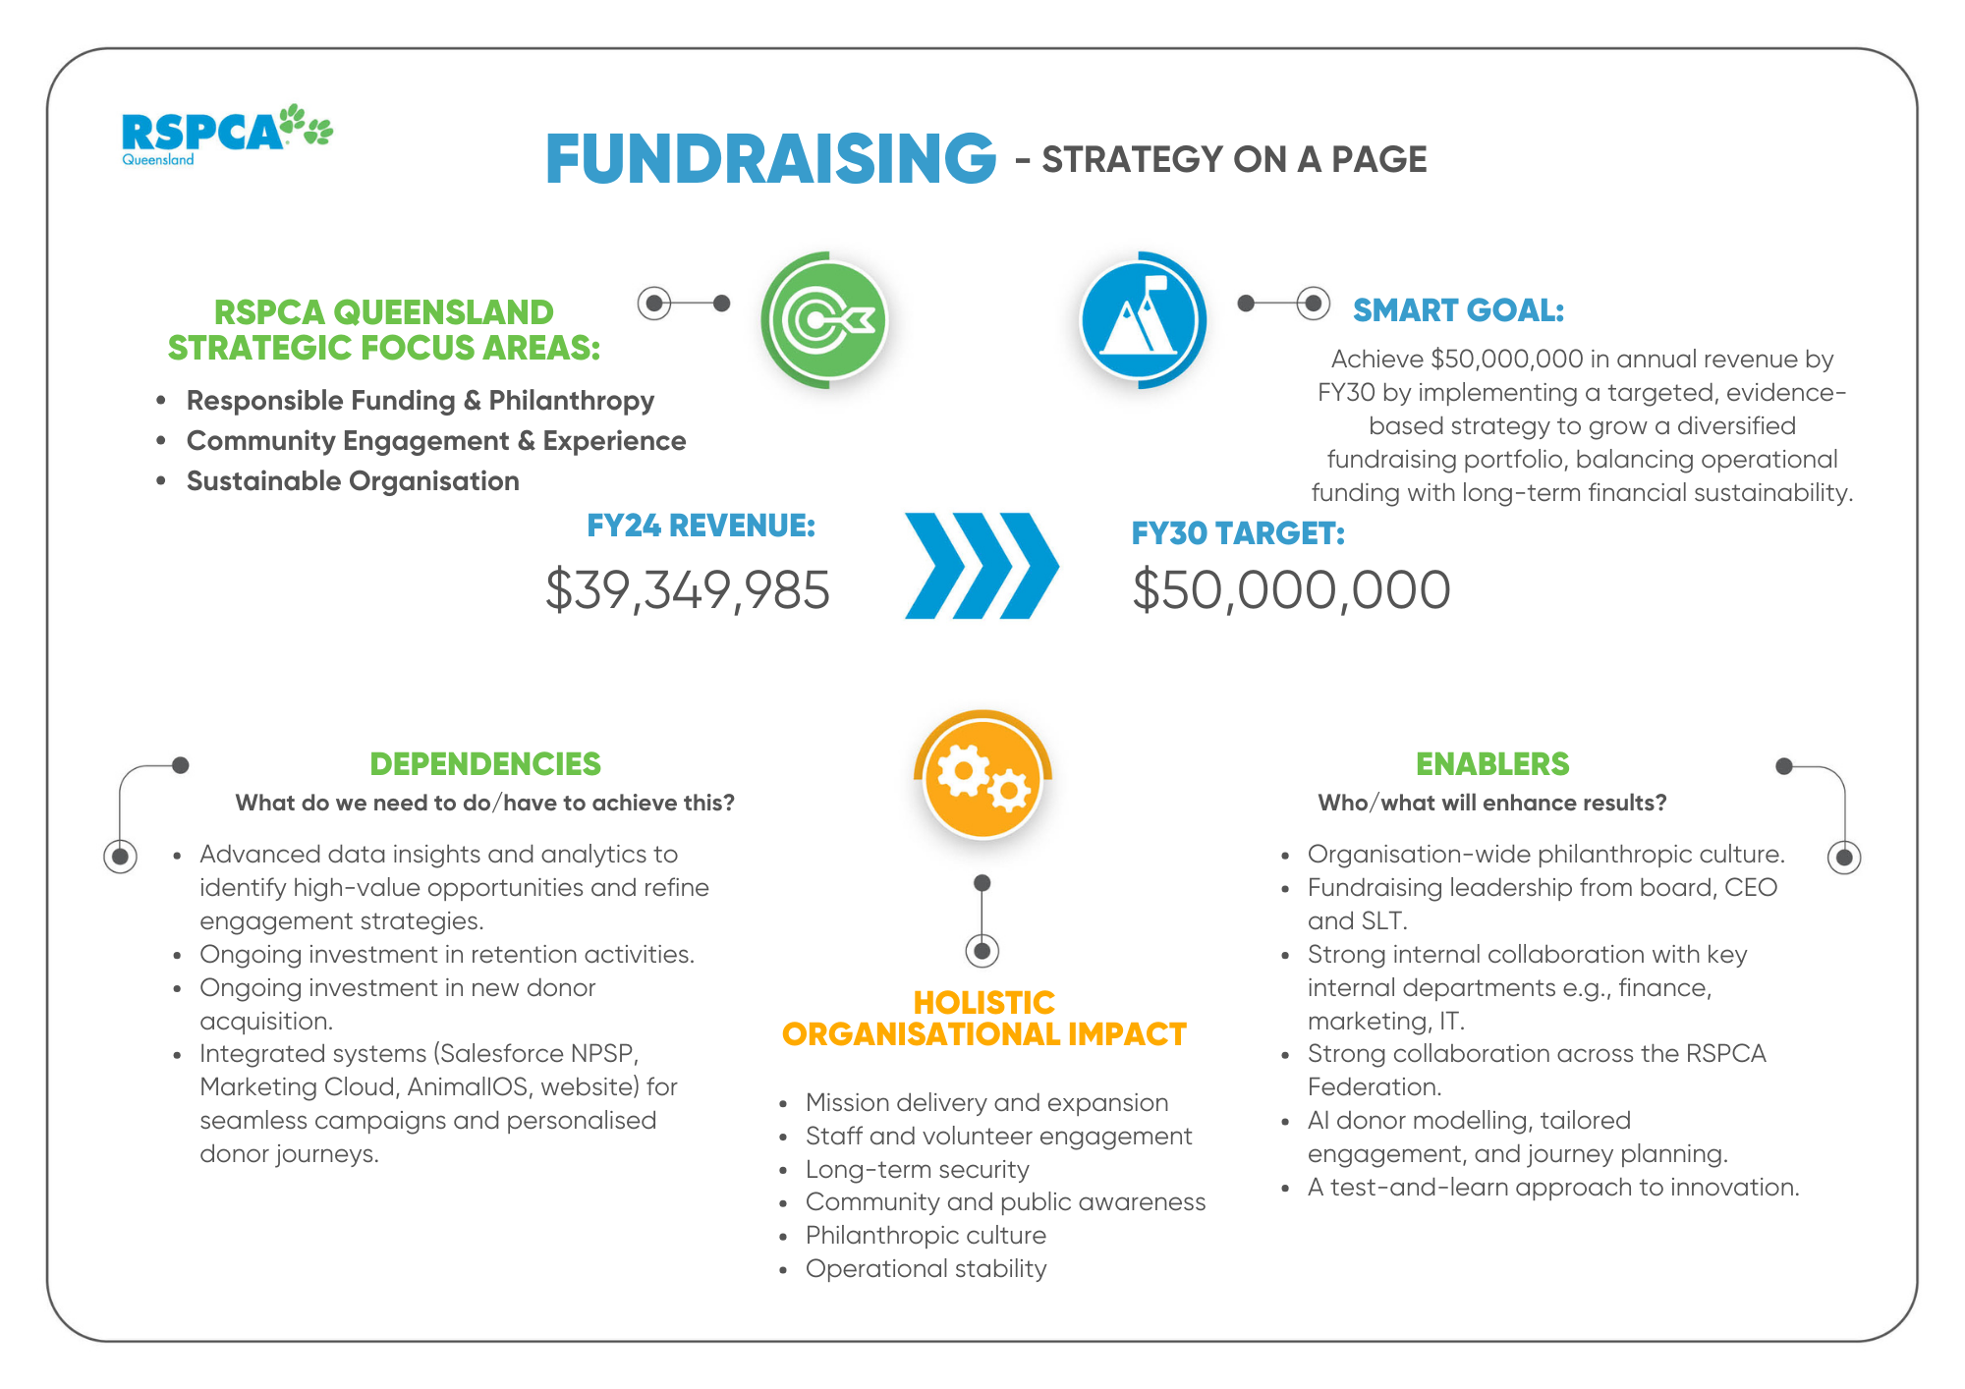
RSPCA QLD Fundraising Structure FY26
Jim Green
GM: Fundraising

Zoe is providing maternity leave cover for Mia (1 FTE)
National Lottery
Adopt-a-Pen
Corporate Experience Days
Partnership Growth & Optimisation
Workplace Giving
Community Fundraising
Donor Services
Supporter Experience
Capital Campaigns
Estates Administration
Appeals
Gifts in Wills
Mid/Major Gifts
Newsletters
Regular Giving
Theresa Scanlan
Philanthropy Manager
Marketing Specialist

Paige Livingstone Marketing Specialist

Angel Morrison
Data & Insights Specialist

Sarah Dunne
Corporate Experience Program Officer

Tara Manning
Partnerships Specialist
(0.8)

Kirsty Moore
National Lottery Manager

Nikki Bird Partnerships Manager

Senior Fundraising Manager
Mitz Wang
Philanthropy Coordinator

Jacquie Kennedy
Philanthropy Specialist

Estelle Riesz
Community Fundraising Coordinator
Aileen McGregor-Lowndes
Philanthropy Specialist
Zoe von Muralt
Supporter Experience Specialist
Lyndal Ferrari Individual Giving Specialist

Mia Fletcher
Supporter Experience Specialist
Sam Sargisson
Fundraising Specialist
(0.8)

Supporter Experience Manager

